# Relational Model

1.Institute(instituteID,name,addr,phone,email,web)

2.Midwife(pracID,name, email, phone,instituteID) instituteID ref Institute

3.Birthingcenter((instituteID) InstituteID ref Institute

4.CommunityClinic(instituteID) InstituteID ref Institute

5.Mother(HCardID,email,dob,name,phone,profession,bloodtype,addr)

6.Father(fatherID,name,HCardID,email,dob,phone,profession, bloodtype,addr)

7.Couple(coupleID,HCardID,fatherID) HCardID ref mother fatherID ref father

8.Technician(tecinstituteID,name,phone)

9.Pregnancy(coupleID, num, expdueym, lmpdued, usounddued, estdued, interested, homebirth, ppracID, bpracID, InstituteID) coupleID ref Couple, InstituteID ref Institute,ppracID ref Midwife,bpracID refMidwife

10.Baby(babyid, gender, dob, btime, bloodtype, bname, pregnum, coupleID) (pregnum, CoupleID) ref Pregnancy

11. Tests(testid, ttype, prescdate, sampdate, labdate, results, pracID, pregnum, CoupleID, babyid, techID) pracID ref Midwife, (CoupleID, pregnum) ref Pregnancy, babyid ref Baby, techID ref Technician

12. InfoSession(infoID, sdate, stime, lang, practid) practid ref Midwife

13. Appointment(appointmentid, adate, atime, pregnum, coupleID, practid, instituteID) (pregnum,coupleID) ref Pregnancy, practid ref Midwife, instituteID ref BirthCenter

14. InfoSessionRegistration(infoID, coupleID, attended)

15. Notes(noteID,appointmentid,content,ndate,ntime) appointmentid ref Appointment

# Pending constraints

1. The tests is not linked to appointment, so there might be case where tests are prescribed by midwives not during appointments; even the tests could be prescribed by the midwife not specifically assigned to that pregnancy.
2. Midwife can be assigned to couples without attending infosessions.
3. A couple could form twice and this info cannot be captured by the database.
4. The database doesn’t prevent pregancy specified to home birth asscociated with midwife in birthing center.
5. The database doesn’t capture which birthing center where the birth will happen, since they can do that in birthing center the midwife does not work in.
6. The tests could be performed on both mother and baby which is not ideal.
7. We cannot add multiple back up midwives. The database doesn’t prevent backup midwife be the same primary midwife.
8. It’s possible that the ultrasounded in pregnancy is changed without by certain tests; this should be restricted in appication side.

# SQL Queries

5a.

select adate,atime,A.HcardID,M.name,M.phone from(

select adate, atime, HCardID from (

select adate, atime,coupleID from Appointment

where practid in (

select pracid from midwife

where name='Marion Girard'

)

and adate>='2022-03-21' and adate<='2022-03-25'

) as A left join couple as C

on A.coupleID=C.coupleID

) as A left join mother as M

on A.HcardID = M.HcardID;

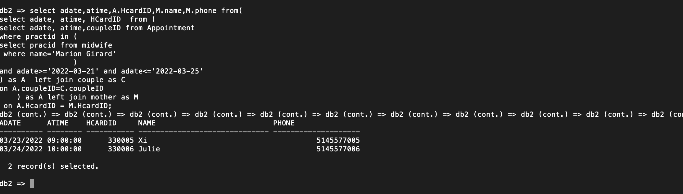

5b.

select results,labdate from Tests

where coupleID in

(

select coupleId

from couple

where hcardid in (

select hcardid

from mother

where name = 'Victoria Gutierrez'

)

) and pregnum=2 and ttype='blood iron'

;

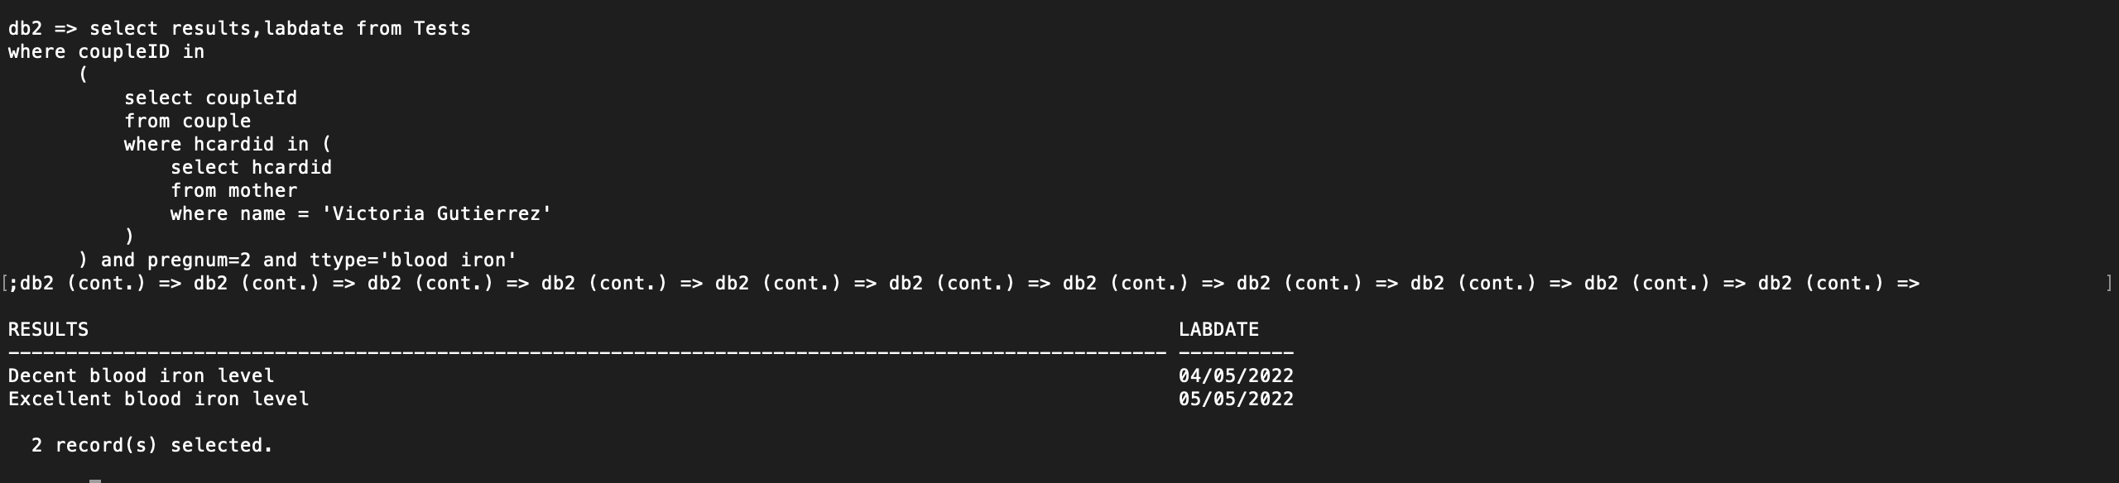

5c.

SELECT NAME,COALESCE(pregdue, 0 ) as pregdue

FROM (

select NAME, pregdue

from INSTITUTE I

left join (select instituteid, count(concat(COUPLEID, expdueym)) as pregdue

from (

select expdueym, instituteid, PPRACID, COUPLEID

from pregnancy

where expdueym <= '2022-07-31' and expdueym >= '2022-07-01'

)

group by instituteid) as A

on I.instituteid = A.INSTITUTEID

);

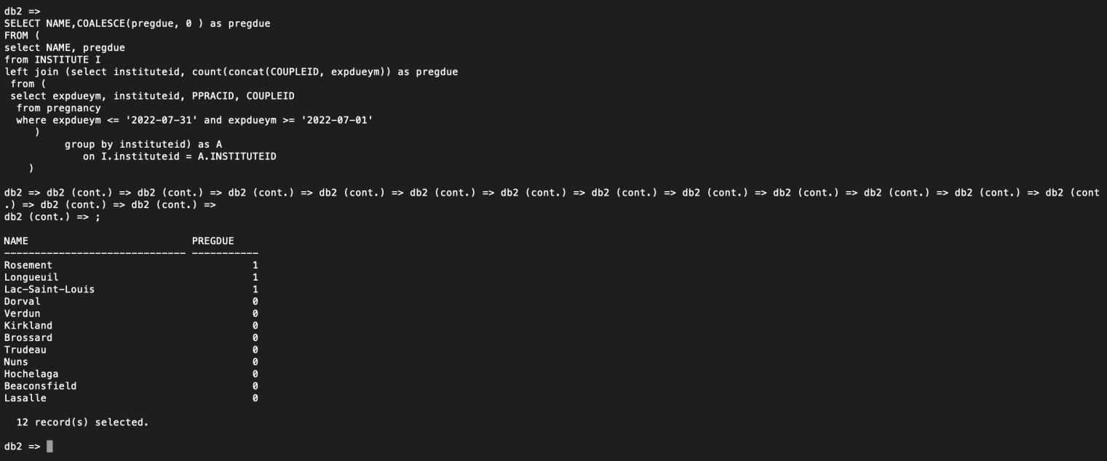

5d.

--pregnant mother

select HcardID,name,phone

from mother where hcardid in (

select Hcardid from couple

where coupleid in (

select coupleid

from (

--pregnant couples not yet born baby

select coupleId

, num

from pregnancy

except

select coupleId

, pregnum

from baby)

INTERSECT

--coupld under care of midwife working for Lac-Saint-Louis

select coupleid

from pregnancy

where ppracID in (

--midwife work for Lac-Saint-Louis

select pracid

from midwife

where instituteID in (

select instituteID

from institute

where name = 'Lac-Saint-Louis'

)

)

--backup midwife

or bpracID in (

--midwife work for Lac-Saint-Louis

select pracid

from midwife

where instituteID in (

select instituteID

from institute

where name = 'Lac-Saint-Louis'

)

)

);

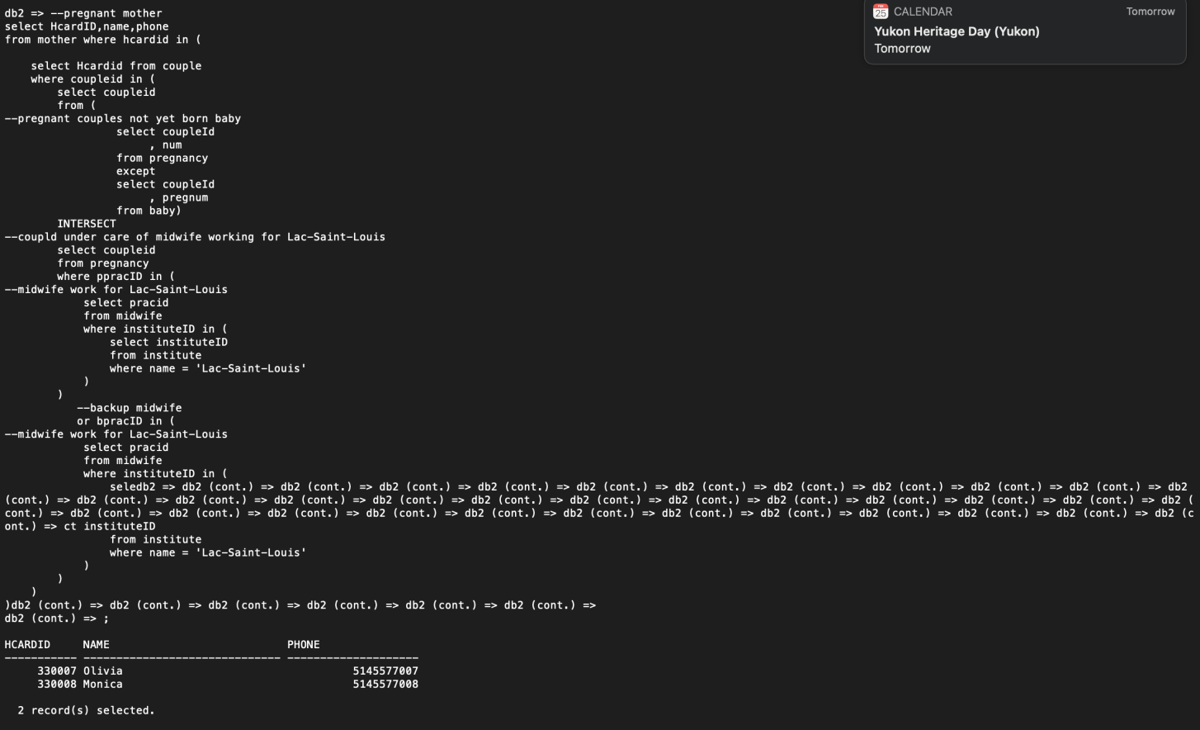

5e.

select hcardid,name from mother where hcardid in(

select hcardid from couple

where coupleid in(

select distinct coupleid from(

--get coupleid for such pregid

select coupleid, concat(concat(coupleid, ':'),num) as pregid

from pregnancy) as A right join (

--get pregnancy with more than 1 baby

select pregid

from (

--get baby number for each pregnancy

select count(concat(concat(coupleid, ':'), pregnum)) as numbaby,

concat(concat(coupleid, ':'), pregnum) as pregid

from baby

group by concat(concat(coupleid, ':'), pregnum)

)

where numbaby > 1) as B

on A.pregid=B.pregid));

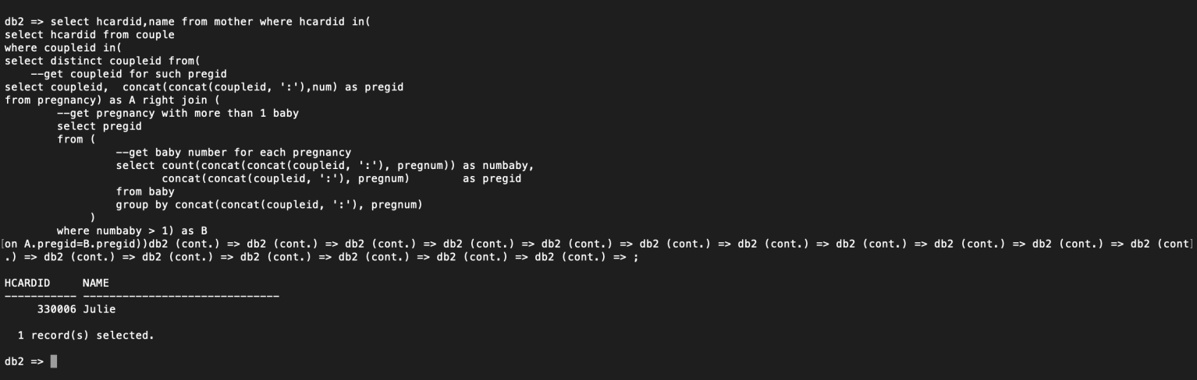

# Midwife Information

6a.

CREATE VIEW midwifeinfo (pracid,midwifename,phone,email,institutename,addr)

AS SELECT m.pracid,m.name as midwifename,m.phone,m.email,p.name as institutename,p.addr

FROM midwife m left join institute P

on m.instituteid = P.instituteid;

6b.

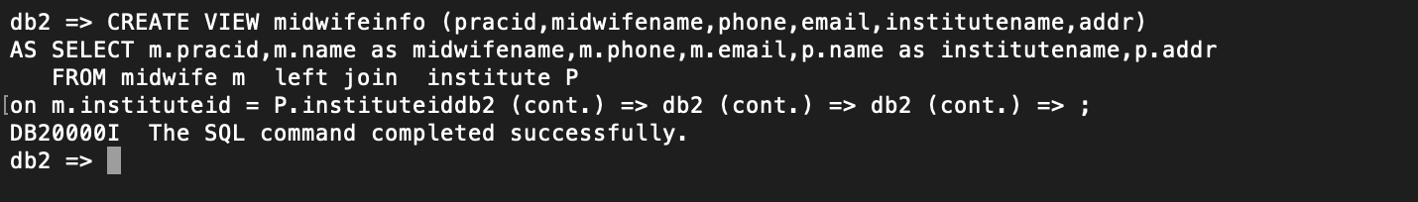

6c.

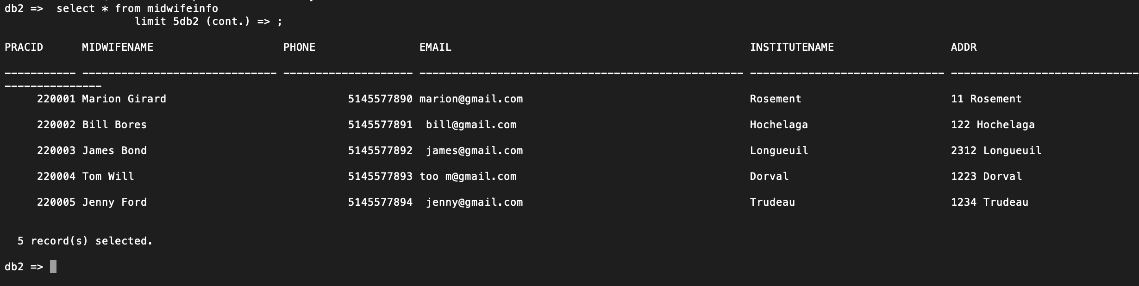

6d.

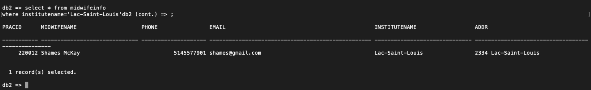

6e.

The insert command fails. The view is virtual but when you do insert it’s in effect with real tables as well. Since midwifeinfo is produced with join command. The database don’t know where to insert data in the two underlying tables.

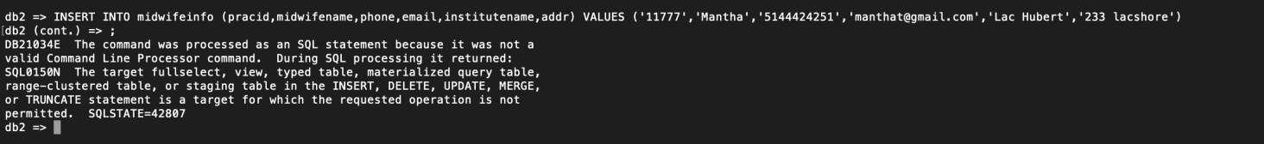

# Check Constraints

Screenshot 2022-02-23 at 10.35.06 PM